

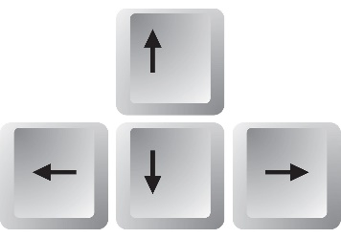

Mouse and Arrow Practice

1. How to use the mouse---“Bees and Honey”

<https://www.tvokids.com/preschool/games/bees-and-honey>

1. Mouse control – “Pop the Balloons”

<http://primarygamesarena.com/Play/Pop-The-Balloon-400>

1. Mouse skills and color practice---“Booples Colors”

<http://www.sheppardsoftware.com/preschool/ngames/colors.htm>

1. Mouse movement skills --- “Collect the Tennis Balls”

<http://boowakwala.uptoten.com/kids/boowakwala-adventures-tennis-collectballs.html>

1. Mouse movement skills --- “Burst the Magic Bubbles”

<http://boowakwala.uptoten.com/kids/boowakwala-family-magic-magicbubbles.html>

1. Click and drag skills --- “Matching Letters”

<https://www.abcya.com/games/uppercase_lowercase_letter_matching>

1. Drag and click skills--- “Digi Puzzles”

<https://www.digipuzzle.net/digipuzzle/animals/puzzles/puzzle_lines.htm?language=english&linkback=../../../index.htm>

1. Drag, click, and mouse control --- “Catching Apples”

<http://primarygamesarena.com/Play/Catching-Apples-397>

1. Drag, click, and mouse control --- “Frost Bite”

<http://primarygamesarena.com/Play/Catch-The-Snow-399>